Morphology

Eric Coyle

6/2/2021

library(tidyverse)

## -- Attaching packages --------------------------------------- tidyverse 1.3.1 --

## v ggplot2 3.3.3 v purrr 0.3.4  
## v tibble 3.1.1 v dplyr 1.0.6  
## v tidyr 1.1.3 v stringr 1.4.0  
## v readr 1.4.0 v forcats 0.5.1

## -- Conflicts ------------------------------------------ tidyverse_conflicts() --  
## x dplyr::filter() masks stats::filter()  
## x dplyr::lag() masks stats::lag()

library(StereoMorph)  
library(ggplot2)  
library(here)

## here() starts at C:/Users/ericc/Desktop/General-Repository

library(ggthemes)  
library(paletteer)  
library(ggpubr)

morphology_data <- readr::read_csv("morphology_data.csv")

##   
## -- Column specification --------------------------------------------------------  
## cols(  
## video = col_character(),  
## body_ram = col_double(),  
## jaw_ram = col_double(),  
## time_ms = col_double(),  
## total_distance_cm = col_double(),  
## proportion_body_ram = col_double(),  
## proportion_jaw_ram = col_double(),  
## gape_cm = col_double(),  
## suction = col_double(),  
## `speed (m/s)` = col_double(),  
## species = col_character()  
## )

head(morphology_data)

## # A tibble: 6 x 11  
## video body_ram jaw_ram time_ms total_distance_cm proportion_body_ram  
## <chr> <dbl> <dbl> <dbl> <dbl> <dbl>  
## 1 ongus1_08 2.74 0.791 26 3.20 0.858  
## 2 fasciatus3_11 1.33 0.792 45 1.92 0.689  
## 3 ongus1_13 4.10 0.765 64 4.55 0.902  
## 4 fasciatus4_17 1.74 0.871 57 2.41 0.721  
## 5 fasciatus4_05 1.76 0.799 53 2.35 0.749  
## 6 ongus4_20 5.07 0.799 36 5.53 0.916  
## # ... with 5 more variables: proportion_jaw_ram <dbl>, gape_cm <dbl>,  
## # suction <dbl>, speed (m/s) <dbl>, species <chr>

morphology_data%>%  
 ggplot(aes(x=proportion_body_ram,y=gape_cm,shape=species,size=`speed (m/s)`))+  
 geom_point()

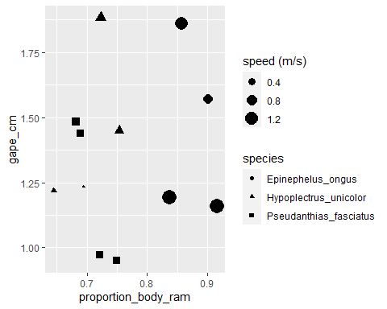

morphology_data%>%  
 ggplot(aes(x=proportion_body_ram,y=gape_cm,size=`speed (m/s)`))+  
 geom_point()+  
 geom_smooth(method = lm,se=F)+  
 stat_regline_equation(label.y=1.9,aes(label = ..eq.label..)) +  
 stat_regline_equation(label.y=1.8,aes(label = ..rr.label..))+  
 theme(legend.position = "right",  
 axis.text.x = element_text(angle = 60, hjust=1,size = 13),axis.title = element_text(size = 16),plot.title = element_text(size = 19,face = "bold",hjust = .5))+  
 labs(title = "The influence of Body Ram on Gape",x="Proportion of Total Distance Covered by Body Ram",y="Gape (cm)")

## `geom_smooth()` using formula 'y ~ x'

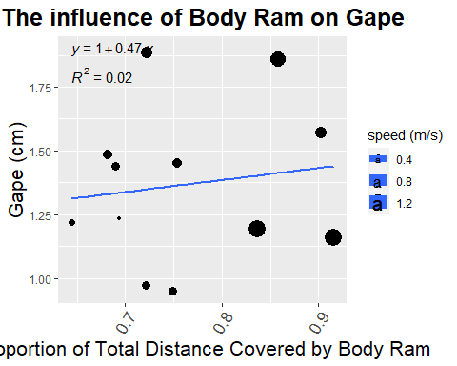

morphology_data%>%  
 ggplot(aes(x=proportion_body_ram,y=gape_cm,size=`speed (m/s)`))+  
 geom_point()+  
 geom_smooth(method = lm,se=F)+  
 stat_regline_equation(label.y=1.75,aes(label = ..eq.label..)) +  
 stat_regline_equation(label.y=1.65,aes(label = ..rr.label..))+  
 theme(legend.position = "right",  
 axis.text.x = element_text(angle = 60, hjust=1,size = 13),axis.title = element_text(size = 16),plot.title = element_text(size = 19,face = "bold",hjust = .5))+  
 labs(title = "The influence of Body Ram on Gape",x="Proportion of Total Distance Covered by Body Ram",y="Gape (cm)")+  
 facet_wrap(~species)

## `geom_smooth()` using formula 'y ~ x'

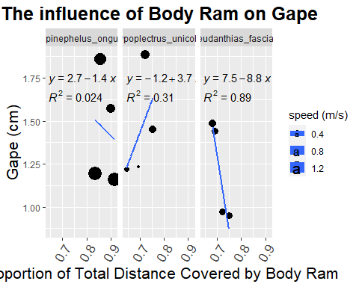

morphology_data%>%  
 ggplot(aes(x=`speed (m/s)`,y=gape_cm))+  
 geom_point()+  
 geom_smooth(method = lm,se=F)+  
 stat_regline_equation(label.y=1.9,aes(label = ..eq.label..)) +  
 stat_regline_equation(label.y=1.8,aes(label = ..rr.label..))+  
 theme(legend.position = "right",  
 axis.text.x = element_text(angle = 60, hjust=1,size = 14),axis.title = element_text(size = 17),plot.title = element_text(size = 20,face = "bold",hjust = .5))+  
 labs(title = "Gape of fish moving different speeds",x="Speed (m/s)",y="Gape (cm)")

## `geom_smooth()` using formula 'y ~ x'

